Oread Neighborhood Association
Thursday, November 19, 2009 @ 8:00 PM
City Hall – Planning Department Conference Room
MINUTES

Attending: Candy Davis, James Dunn, Marci Francisco, Linda Haskins, Ellie LeCompte, Kyle Thompson, and Carol vonTersch

Guests:
Nancy Dunn – Oread Neighbor
Elise Higgins – Director, Student Senate Community Affairs,
Mark Thiel – Assistant Public Works Director, City of Lawrence
Tyler Means and Matt Baker – KU Students, Course: Community Development / Urban Planning w/ Professor Daniel Cerda

KU Student Senate Off-Campus Lighting Project
12th Street Route

Guests Elise Higgins and Mark Thiel spoke with neighbors about a proposed off-campus lighting project that will be routed through the Oread neighborhood.

Project Overview:
- Route: ONA Board member Marci Francisco spent several hours walking through the neighborhood with Elise and Mark to identify potential routes for the project. Several routes have been discussed. The objective is to create lighted pathways from campus to downtown so that pedestrians can navigate back and forth between these areas with an increased level of safety. Two routes have been proposed; a primary and a secondary.
  - Primary: 12th Street east from Oread Avenue to Vermont, Vermont through South Park (diagonally through the park and come out at north park and Massachusetts).
  - Secondary: 14th Street from Louisiana to Ohio, north on Ohio to 12th Street and tie into the existing primary route.
- Lighting: Consideration has been given to the potential for “light pollution” and how this will impact Oread residents. Lights selected for the project:
  - Dimensions: 3-4 feet tall / 9” in diameter,
  - Installation: Mounted on top of concrete pedestals,
  - Activation: Motion activated via a microwave sensor. Lights can be adjusted and set for certain distances. When activated, the lights transition from dim to bright. A sample has been ordered and will be installed to see how well it works.
  - Vandalism: Neighbors expressed concern about vandalism and the likelihood that the lights will be broken. Replacement / maintenance costs need to be a high priority.
- Sidewalks:
  - Sidewalks will be repaired/replaced along the proposed path. Walkways will be 5’ wide, ADA compliant, and will be located in the public right of way. This work will be paid for by funding procured for the project.
  - Ongoing sidewalk maintenance has been considered but no decisions have been made. This will have to be decided at a higher level; perhaps as part of the City’s budget.
  - Sidewalks will be ADA compliant.
- Funding: The total cost of the proposed project is estimated to be $650,000. The following funding opportunities have been identified:
  - KU Student Senate: $20,000
  - Community Development Block Grant Funds: $200,000
  - Transportation Enhancement Grant – Kansas Department of Transportation: $250,000
  - KU Funding: $150,000
  - City of Lawrence: $50,000
- Historical Review: There will be reviews based on two sets of criteria; the City of Lawrence Historic Resources Commission and State Historical Review.
  - Taller light posts with a historic character were considered for this project. According to Lynne Zollner, reproductions of historic lighting would not be in keeping with the historic character of the neighborhood.
FOLLOW UP: It was later learned that this was a misconception and lighting designed to be in character with the historic character of the neighborhood can be considered.

Neighborhood Discussion
- The need to increase lighting for pedestrian traffic has been added to the neighborhood plan.
- Neighbors present at the monthly meeting would like to walk the proposed pathways so that they will have a clear understanding about where the routes will be located. A high volume of pedestrian traffic will be funneled along the pedestrian pathways if this project is implemented.
  - Walkways will be dangerous in the winter.
  - The increase in pedestrian traffic along the routes will be cause for additional loose trash in these areas.
- Neighbors were not in favor of having motion activated lighting installed in front lawns. Side yard lighting is preferred and will have less of an impact on streetscapes.
- A letter of support will be sought from the neighborhood prior to submission of a Transportation Enhancement Grant. This grant will be due at the end of 2009.
- An e-mail will be sent to Mark Thiel on or before Wednesday, December 2nd, stating that there is interest in having a safe, walkable neighborhood that includes additional lighting.
- Input must be solicited from Oread property owners along the proposed pathways. Their input is vital to the potential success of this project. The Oread Neighborhood Association cannot officially speak on behalf of neighbors without speaking with the property owners and residents first. Elise Waldron will prepare a one page summary of the project to share with the neighbors. Property owners along the route can be identified via the on-line Douglas County Online Value & Taxes website located at:
http://www.douglas-county.com/online_services/valuestaxes/disclaimer.asp?category_id

City Agendas

Board of Zoning Appeals, November 5th Meeting
http://www.lawrenceplanning.org/documents/bzaagendaNov09.pdf
  - Item No. 5: Sunflower House – 1406 Tennessee Street: Request for variances WITHDRAWN.

Historic Resources Commission, November 19th Agenda http://www.lawrenceplanning.org/documents/hrcagendaNov09.pdf

Oread Neighborhood Plan

The following items were discussed by the HRC at the November 19th Meeting:

Proposed Density
- District 1 – Low density district
- District 2 – Higher density district. Multi-family residential area available for KU student housing.
- District 3 – Medium density district

Proposed Boarding House Text Amendment - Parking
One parking spot per bedroom was proposed for boarding houses.
- It was decided that this was too specific for the plan at this time and should not be implemented as a citywide requirement.
- This is an item that can be addressed in overlay districts in the future.

Public Comment:
- Duplexes, Boarding Houses and Parking Requirements: The development of duplexes and boarding houses is compromising the stability of the neighborhood. This has been particularly evident in District 2, north of the KU football stadium, which is an area that is not protected by a historic district. Requiring one parking space per bedroom for boarding houses would be consistent with parking requirements in other areas in the multi-family districts.
- Lawrence Preservation Alliance – Dennis Brown: Urban conservation overlay districts will need to be compared with historic design guidelines. Identification of overlay districts will begin after the neighborhood plan has been completed.
- Neighborhood History: An accurate history will be an important part of the neighborhood plan. For example, it will be important to identify specific structures that survived Quantrilles raid, etc.
- Development Challenges: Areas similar to the 1100 block of Ohio will be difficult to redevelop because of the steep slopes without an alley. South a number of older structures in those blocks w/ steep slopes. These areas need to be identified as ones that will be difficult to redevelop to high density in the proposed Districts 2 and 3.
- East Lawrence Support: A representative from the East Lawrence neighborhood association spoke in support of the Oread neighborhood’s efforts to revise the plan. Strong support was also expressed for the boarding house parking requirements that the neighborhood would like to see (i.e.: require 1 space per bedroom).

Commission Discussion:
- Commission Action: HRC members supported the proposal to defer this item by one month to allow more time to review the details of the plan.
- Planning Commission: The PC is generally in support of the outlined district concepts. More information about the districts needs to be included in the revised plan.
- Language in Document: Instead of using terminology like, “Consider creating…” this could be changed to be more direct. For example, “We create…” instead. Consistency and clarity of purpose needs to be built in throughout the document.
- Overlay Challenges for Implementation: Are three districts reasonable? Yes… these are linked to historic districts (state / federal law – guidelines). One conservation district could have two zones to help refine definitions in the area. This will be a good for the goals that are being defined.

Action:
- Defer action until December meeting.

1205 Kentucky – Demolition of Garage

Applicant Discussion:
- This area in the neighborhood does not have garages at every property. There are thirteen houses along the alley with garages belonging to only four of them. It is the property owner’s opinion that the deteriorated garage should not be considered a character defining structure in this area.
- Damage to the structure was caused by vehicles backing into it. To rebuild, the garage would need to be repositioned in order to allow room for the size of vehicles currently being used. This could diminish the amount of parking at this location.

Public Comment:
- This is a concern for the neighborhood because it represents demolition by neglect. Allowing property to deteriorate into this condition is unreasonable.
- Alleys are part of the historic pattern of the neighborhood. The presence of garages may help to encourage owner occupants back into the neighborhood. Lack of garages down an alley could discourage owner occupants from wanting to invest in properties in the neighborhood. There is an appreciation for having some things that break up the alley landscape. Properties listed on register / district nominated encourages holding on to historic fabric as much as possible.

Commission Discussion:
- There are five garages in the alley and two are in about the same condition.
- Accessory structures do lend to the character of an alley. Should the HRC facilitate the new development pattern or ensure that historic trends are upheld.
- The HRC does support the intent to rehabilitate the house.
- This garage is not salvageable. Commissioners were disappointed that this is a demolition by neglect. The structure has been deteriorating for an extended period of time.
- MOTION: Approve the proposed demolition with the determination that this does not adversely affect the environs.

The neighborhood will contact the City about why this was not cited as a blighted property in need of repair.

Planning Commission, October 26th Agenda
http://www.lawrenceplanning.org/documents/pcagendaOct09.pdf
  - Amendments to development code: Boarding House (SDM): Consider text amendments to various sections of the City of Lawrence Land Development Code to review standards related to “Boarding House.” Deferred from 9/21/09 Planning Commission.

October 30th email: Hello Scott. Wow, I certainly appreciate your efforts to present logical amendments to the planning code regarding boarding houses on Monday 10-26-09. I of course believe it is the right thing to do. A major unintended consequence if the parking requirement is not changed, may be that all other multi/units that have higher parking requirements will want the same lower parking requirements as "congregate living". Parking requirements have been working well in our neighborhood for many years. The exception is the recent twist on the boarding house definition-which was never intended to be used in such a manner. We know that it is a loop hole that recent developers are benefiting from financially. I certainly object to Mr. Finkledei's perspectives on parking in Oread. I don't think the City is ready to take on the expense of a permit parking program to solve our parking issues. Preventive measures make much more sense.
Will there be public comment at the next PC meeting on this amendment? ONA neighbors were not prepared for the turn out of most all of the boarding house owners at the last meeting. Many more people from all over the community supporting the amendment will be present at the next meeting.

Planning Commission, November 16th Agenda
http://www.lawrenceplanning.org/documents/pcagendaNov09.pdf
  - Special Use Permit for Lawrence Community Shelter: Consider SUP for a new location at 2176 E 23rd Street (former Don’s Steak House).

Planning Commission, November 18th Agenda
http://www.lawrenceplanning.org/documents/pcagendaNov09.pdf
  - Comprehensive Plan Amendment to Chapter 14: Consider a Comprehensive Plan Amendment to Chapter 14 – Specific Plans to approve and incorporate by reference the Oread Neighborhood Plan.

Planning Commission, December Agenda (PENDING)
  - Boarding House Text Amendment and Oread Neighborhood Plan to be considered.

Boarding Houses
November 4th email: Some or all of us need to meet soon to discuss what we can do to promote the text amendments that were proposed by the planning department last week. They made a lot of sense to us and would go a long way to curb the tide of "boarding houses". As you may know the proposal was met with much opposition by the boarding house owners. We need much more support at the next meeting in early December with the Planning Commission. I am presently working on information to share with LAN tomorrow in order to get support from other neighborhoods. We need to have lots of individuals besides our usual spokespersons to speak up to support the amendments.
AMENDMENT:
- Parking requirements of one space per bedroom not 1.5 per 2 individuals.
- Space for a trash receptacle on the site plan.
- Planning even purposed having a contact person or responsible person living in the house.

Keep in mind, the code requirement for all other rentals is 1 parking space per bedroom. An unintended consequence of not making parking standards uniform in multi-family zoned areas is that the others will want less parking.

Neighborhood Plan
The revised draft has been posted at: http://www.lawrenceks.org/pds/draft_plans

Proposed Meeting to discuss the Neighborhood Plan and the Boarding House amendment: Saturday, November 21st; Time and Location: Pending

Demolition Permits and Blight

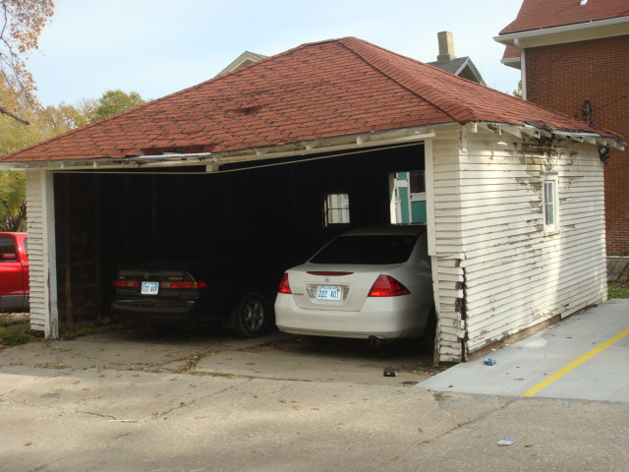
1205 Kentucky (Demo): See HRC discussion above.
Property Owners: Theodore “Ted” H. & Marcia L. McFarlane (Overland Park, KS)
Application Date: 10/12/09 (30-day Public Comment Period)
Description of Structure: Detached, 2-car Garage, wood frame, asphalt shingle roof.

1022 Alabama (Demo)
Property Owners: Ziegler Rentals, LLC – Brad Ziegler, 5008 Keystone Ct, Lawrence
Application Date: 11/09/09 (30-day Public Comment Period)
Description of Structure: Four bedroom residence.
Applicant: Tiffany Ruse for Paul Werner Architects

1129 Vermont – Owner: Robert Garcia (Blight) – House burned in December 2007
November 2009: Note from Brian Jimenez, Code Enforcement Manager, read, “I met with the owner at the site about two weeks ago. At that time there were some minor exterior yard violations that have been taken care of. Regarding the rehabilitation, he plans to resubmit a building permit application to Barry Walthall in the near future.

Discussion Items

December Neighborhood Meeting
A date and location needs to be identified for the December meeting. Jerry will need to post this on the ONA website when confirmed.

New District Representative Needed – District 6 (Christy Kennedy)
Christy would like to step down from her position. Does anyone know of someone in her district that could take her place? District six occupies the southern boundary of the neighborhood. 14th and 15th Streets border the north and 17th Street borders the south.

Portapotties
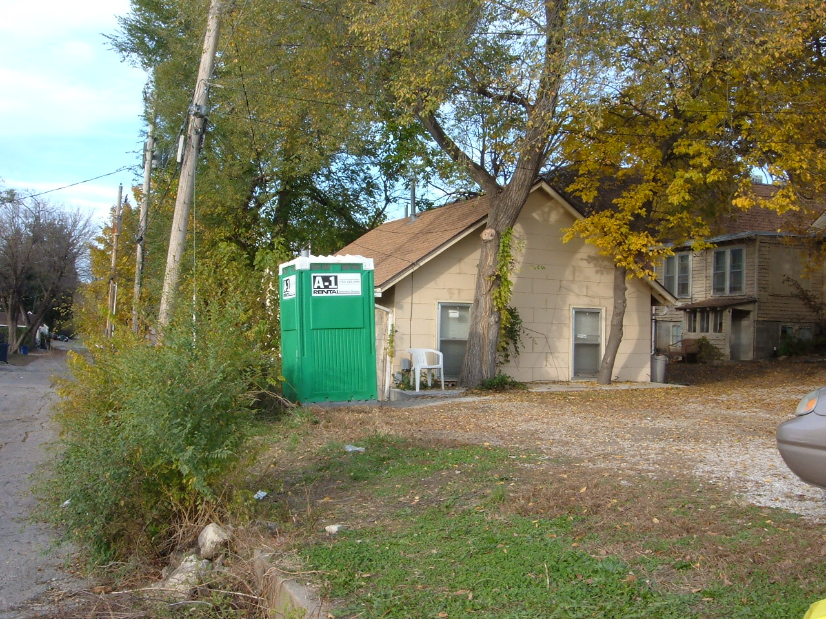
From email dated October 30, 2009: It seems that there is no ordinance in place for the use of portapotties on private property but even the portapotty company that delivers and services them said they had never had an order for so many in one area before this year(I counted nine addresses just north of the stadium, some with more than one unit). They have been providing a few in the past. They will all leave after the last game Nov. 14, so he said that takes care of it for this year, but for next year, they can look at what to do about it. He said that although they are not in violation now, that doesn’t mean it can’t be changed in the future.
So, it seems to be a growing issue in Oread only, and if we as an association want to do something about it before next year (when theoretically, every house could display one for three months) we will have to decide what to suggest to the city. Could we put this in the next meeting discussion?

From email dated November 10, 2009: During past years as the KU Basketball team moved closer to a national championship--the late night crowds in the Northeast Quadrant of the "hood" increased beyond the ability of the business district to accommodate the bodily needs of the revelers--the number of individuals utilizing the 900 Block of Kentucky (just beyond the business district) for a toilet was noticeably disturbing. After one of the major games, I contacted the city manager's office at city hall with a request for portable toilets in this area before the next game. My request was not honored--not even a call back. As the desperation of the revelers at the next game neared toilet chaos, I asked the Lawrence Community Shelter to open their day side to accommodate those most anxiously seeking relief. Contrary to LCS night policy, the staff opened their facility. As city staff and the community address the placement of portapotties--any major activity or event which generates a crowd beyond which the community is unable to provide facilities--should be considered in the discussions.

FYI and Reminders

ONA Financials – November 2009
Treasurer Account: $7,429.40
Coordinator Account: $193.79 (11/27 Payroll pending)
ONA Membership Income – Budget Year 2009 (August 2009 thru July 2010): $230

Historic Survey – District 1 – Did the Request for Proposal (RFP) Get Published?
November 2009: A note from Lynne Zollner read, “Not yet – got pulled in another direction. It is on my work schedule for the weekend.”
- The RFP is an invitation for suppliers, often through a bidding process, to submit a proposal on a specific service. When a supplier is selected, the survey work can then begin. (I think that’s right)

Duplex Variances in Oread – Will this be considered before the end of the year?
Building permits are being issued prior to requiring a variance.
November 2009: A response from Scott McCullough is pending.

KU-City Agreement: Five Year Review – Will this be considered before the end of the year?
November 2009: A response from Dave Corliss is pending.

1232 Louisiana: Demolition approved by the City Commission on 08/12/08. The structure was demolished on Thursday, October 15th. Demolition was approved with conditions that included:
Neighborhood Plan: This will need to be updated prior to building a replacement structure.
Parking: Following demolition, the property cannot be used as a parking lot.

Expansion of Rental Licensing and Inspection Program: Note from Brian Jimenez dated 04/23/09 read:
Sorry for the delay, it's been one those weeks so far. As far as I know, the City Commissioners, new and old have stated they do not wish to proceed at this point in time and David Corliss will not be recommending going forward at this point. As you know, this topic has been hot and cold for the last several years therefore I imagine
something could change but I do not foresee that happening. I do think some sort of expansion will eventually occur. The big question right now, is when that would happen. I hope that helps.

Graffiti Removal: Check out http://www.nps.gov/history/hps/tps/briefs/brief38.htm

